ADVANCED MICROPROCESSOR SYSTEMS
MAY/JUNE-2006

QUESTION NUMBERS

1,11 –SHAMLY MATHEW
2,12-SHARANYA VINOD
3,13-SHERIN BABU
4,14-SHRUTI PREMAN
5,15-SOMY JOSE
6,16-SONIA JOHN
7,17-SONA RATHI
8,18-SUHANA LIYAKATH
9,19-SUPARNA S
10,20-SUSAN ABRAHAM

1.What is USART? Explain

8251 UNIVERSAL SYNCHRONOUS ASYNCHRONOUS RECEIVER TRANSMITTER (USART)

The 8251 is a USART (Universal Synchronous Asynchronous Receiver Transmitter) for serial data communication. As a peripheral device of a microcomputer system, the 8251 receives parallel data from the CPU and transmits serial data after conversion. This device also receives serial data from the outside and transmits parallel data to the CPU after conversion.

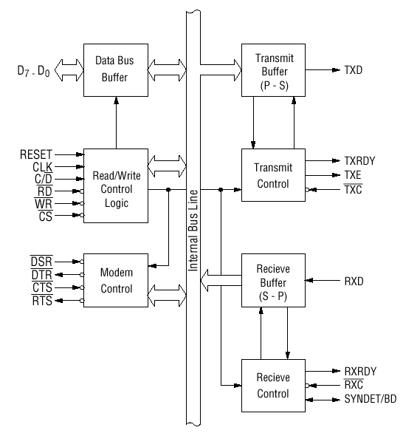
Block diagram of the 8251 USART (Universal Synchronous Asynchronous Receiver Transmitter)

Pin Description

D 0 to D 7 (l/O terminal)

This is bidirectional data bus which receive control words and transmits data from the CPU and sends status words and received data to CPU.

RESET (Input terminal)

A "High" on this input forces the 8251 into "reset status." The device waits for the writing of "mode instruction." The min. reset width is six clock inputs during the operating status of CLK.

CLK (Input terminal)

CLK signal is used to generate internal device timing. CLK signal is independent of RXC or TXC. However, the frequency of CLK must be greater than 30 times the RXC and TXC at Synchronous mode and Asynchronous "x1" mode, and must be greater than 5 times at Asynchronous "x16" and "x64" mode.

WR (Input terminal)

This is the "active low" input terminal which receives a signal for writing transmit data and control words from the CPU into the 8251.

RD (Input terminal)

This is the "active low" input terminal which receives a signal for reading receive data and status words from the 8251.

C/D (Input terminal)

This is an input terminal which receives a signal for selecting data or command words and status words when the 8251 is accessed by the CPU. If C/D = low, data will be accessed. If C/D = high, command word or status word will be accessed.

CS (Input terminal)

This is the "active low" input terminal which selects the 8251 at low level when the CPU accesses. Note: The device won’t be in "standby status"; only setting CS = High.

TXD (output terminal)

This is an output terminal for transmitting data from which serial-converted data is sent out. The device is in "mark status" (high level) after resetting or during a status when transmit is disabled. It is also possible to set the device in "break status" (low level) by a command.

TXRDY (output terminal)

This is an output terminal which indicates that the 8251is ready to accept a transmitted data character. But the terminal is always at low level if CTS = high or the device was set in "TX disable status" by a command. Note: TXRDY status word indicates that transmit data character is receivable, regardless of CTS or command. If the CPU writes a data character, TXRDY will be reset by the leading edge or WR signal.

TXEMPTY (Output terminal)

This is an output terminal which indicates that the 8251 has transmitted all the characters and had no data character. In "synchronous mode," the terminal is at high level, if transmit data characters are no longer remaining and sync characters are automatically transmitted. If the CPU writes a data character, TXEMPTY will be reset by the leading edge of WR signal. Note : As the transmitter is disabled by setting CTS "High" or command, data written before disable will be sent out. Then TXD and TXEMPTY will be "High". Even if a data is written after disable, that data is not sent out and TXE will be "High".After the transmitter is enabled, it sent out. (Refer to Timing Chart of Transmitter Control and Flag Timing)

TXC (Input terminal)

This is a clock input signal which determines the transfer speed of transmitted data. In "synchronous mode," the baud rate will be the same as the frequency of TXC. In "asynchronous mode", it is possible to select the baud rate factor by mode instruction. It can be 1, 1/16 or 1/64 the TXC. The falling edge of TXC sifts the serial data out of the 8251.

RXD (input terminal)

This is a terminal which receives serial data.

RXRDY (Output terminal)

This is a terminal which indicates that the 8251 contains a character that is ready to READ. If the CPU reads a data character, RXRDY will be reset by the leading edge of RD signal. Unless the CPU reads a data character before the next one is received completely, the preceding data will be lost. In such a case, an overrun error flag status word will be set.

RXC (Input terminal)

This is a clock input signal which determines the transfer speed of received data. In "synchronous mode," the baud rate is the same as the frequency of RXC. In "asynchronous mode," it is possible to select the baud rate factor by mode instruction. It can be 1, 1/16, 1/64 the RXC.

SYNDET/BD (Input or output terminal)

This is a terminal whose function changes according to mode. In "internal synchronous mode." this terminal is at high level, if sync characters are received and synchronized. If a status word is read, the terminal will be reset. In "external synchronous mode, "this is an input terminal. A "High" on this input forces the 8251 to start receiving data characters.
In "asynchronous mode," this is an output terminal which generates "high level” output upon the detection of a "break" character if receiver data contains a "low-level" space between the stop bits of two continuous characters. The terminal will be reset, if RXD is at high level. After Reset is active, the terminal will be output at low level.

DSR (Input terminal)

This is an input port for MODEM interface. The input status of the terminal can be recognized by the CPU reading status words.

DTR (Output terminal)

This is an output port for MODEM interface. It is possible to set the status of DTR by a command.

CTS (Input terminal)

This is an input terminal for MODEM interface which is used for controlling a transmit circuit. The terminal controls data transmission if the device is set in "TX Enable" status by a command. Data is transmittable if the terminal is at low level.

RTS (Output terminal)

This is an output port for MODEM interface. It is possible to set the status RTS by a command.

2.Give the control word format of 8255 and explain.

8255 contains a 8-bit control register and contents of this register are called the control word, which specify an I/O function for each port. This register can be accessed to write a control word when A₀ and A₁ are at logic 1. The register is not accessible for a read operation.

Control word for I/O mode operation
bit | function
D7 | D7=1 MEANS I/O MODE  D7=0 MEANS BSR MODE
D6 D5 | D6 D5=0 0 MEANS MOD 0  D6 D5=0 1 MEANS MOD 1  D6 D5=1 x MEANS MOD 2
D4 | CONTROLS PORT A  D4=1 MEANS INPUT OPERATION  D4=0 MEANS OUTPUT OPERATION
D3 | CONTROLS PORT C UPPER  D3=1 MEANS INPUT OPERATION  D3=0 MEANS OUTPUT OPERATION
D2 | D2=0 MEANS MOD 0  D2=1 MEANS MOD 1
D1 | CONTROLS PORT B  D1=0 MEANS OUTPUT OPERATION  D1=1 MEANS INPUT OPERATION
D0 | CONTROLS PORT C LOWER  D0=0 MEANS OUTPUT OPERATION  D0=1 MEANS INPUT OPERATION

Control word for BSR mode operation

bit | function
D7 | FOR BSR MODE D7 SHOULD BE ZERO
D6 D5 D4 | NOT USED IN BSR MODE
D3 D2 D1 | USED TO SELECT THE BIT
D0 | USED TO SET OR RESET THE BIT

3.What is an interrupt? How the interrupt helps for interfacing I/O devices to the processor?

The interrupt I/O is a process of data transfer whereby an external device or a peripheral can inform the processor that it is ready for communication and it requests attention. The process is initiated by an external device and is asynchronous, meaning it can be initiated at any time without reference to the clock.However the response to an interrupt is controlled by the microprocessor.
Interrupts play an important role in the interfacing of I/O devices. For eg in
8279 the IRQ pin is an interrupt request pin which goes high whenever there is a data in the RAM which needs to be read by the CPU.

5. What is PSW of a processor? Give the 8086 PSW format

Program status word ( PSW ) A collection of information that encapsulates the basic execution state of a program at any instant. It permits an interrupted process to resume operation after the interrupt has been handled. The information is held in the program status register , and usually contains the value of the program counter .
- Flag Register (PSW)
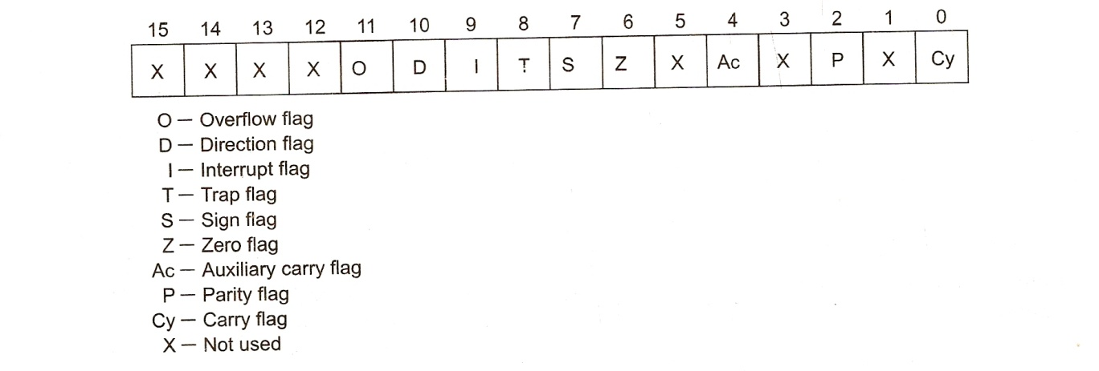
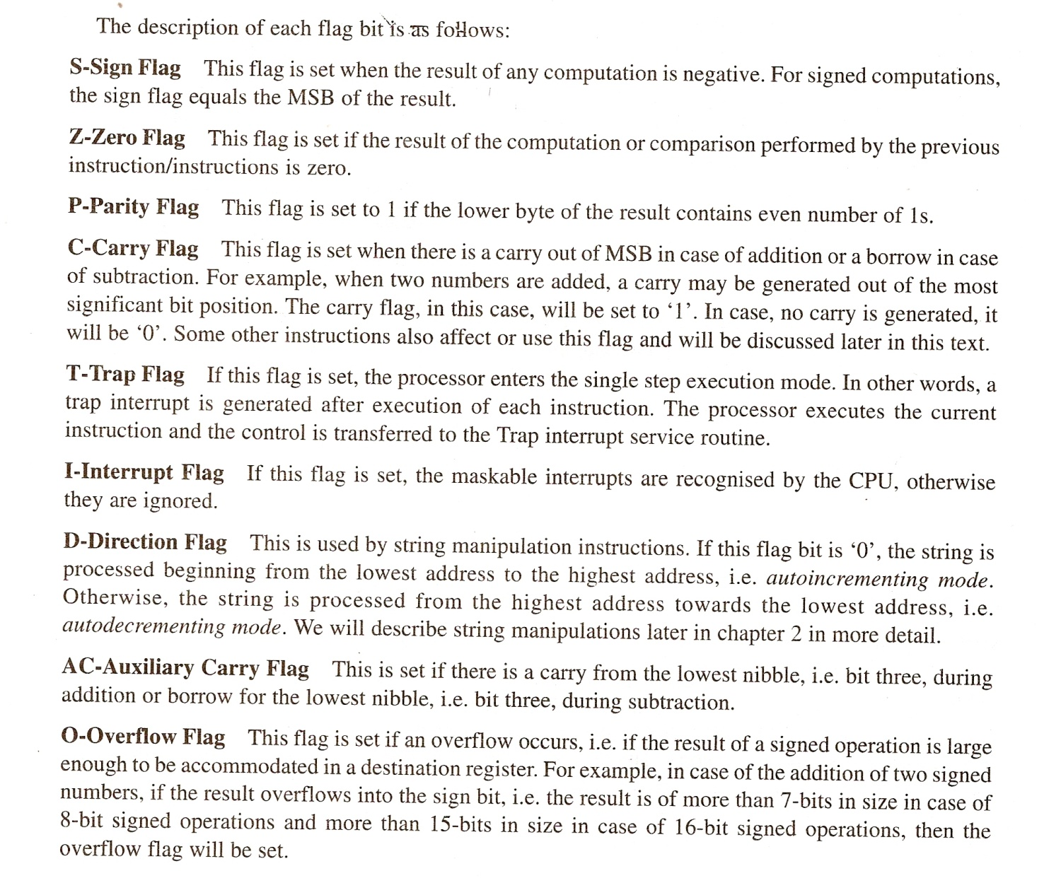
6.Compare minimum and maximum mode operations of 8086 processor?
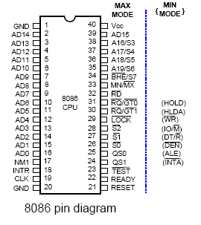
The following pins function in the maximum mode.
- ,-request or grant-these pins are used to force the processor to free the buses
S2,S1,S0-this indicates which type of operation is done by the processor
- -this indicates other system bus masters will be prevented from gaining the bus.
QS1,QS0-this gives information about the code prefetch queue.
The following pins function in the minmum mode
- -This is equivalent to s2 in maximum mode.when low,it indicates that it cpu has an i/o operation.
INTA-when low it indicates that processor has accepted the interrupt.
-The output is used to fin the direction of data flow.
ALE-This shows the availability of valid address on address or data lines.
- -This indicates the availability of valid data on address/data lines.
HOLD/HLDA-It indicats that another master is requesting the bus access.

7. Describe the following instructions

1.)LEA
Load effective address: The load effective address instruction loads the effective address formed by destination operand into the specified source register. This instruction is more useful for assembly language rather than for machine language.
E.g.: LEA BX,ADR :Effective address of label ADR i.e., offset of ADR will be transferred to register BX.

2.)WAIT
- Wait for test input pin to go low.
The WAIT instruction when executed, holds the operation of processor with the current status till the logic level on the TEST pin goes low. The processor goes on inserting WAIT states in the instruction cycle, till the TEST pin goes low. Once the test pin goes low,it continues further execution.

3.)ESC
- Escape to external device like NDP (numeric co-processor)
ESC instruction when executed frees the bus for an external master like a coprocessor or peripheral devices.

4.)STI
-Set interrupt flag
The STI instruction is a flag manipulation instruction which modifies the interrupt flag directly. It sets the interrupt flag.

8. What is the difference between near call and far call instructions?
• Near call—A call to a procedure within the current code segment (the segment currently pointed to by the CS register), sometimes referred to as an intrasegment call.
• Far call—A call to a procedure located in a different segment than the current code segment, sometimes referred to as an intersegment call.

Near Call. When executing a near call, the processor pushes the value of the EIP register (which contains the offset of the instruction following the CALL instruction) onto the stack (for use later as a return-instruction pointer). The processor then branches to the address in the current code segment specified with the target operand. The target operand specifies either an absolute offset in the code segment (that is an offset from the base of the code segment) or a relative offset (a signed displacement relative to the current value of the instruction pointer in the EIP register, which points to the instruction following the CALL instruction). The CS register is not changed on near calls.
For a near call, an absolute offset is specified indirectly in a general-purpose register or a memory location (r/m16 or r/m32). The operand-size attribute determines the size of the target operand (16 or 32 bits). Absolute offsets are loaded directly into the EIP register. If the operand-size attribute is 16, the upper two bytes of the EIP register are cleared to 0s, resulting in a maximum instruction pointer size of 16 bits. (When accessing an absolute offset indirectly using the stack pointer [ESP] as a base register, the base value used is the value of the ESP before the instruction executes.)
A relative offset (rel16 or rel32) is generally specified as a label in assembly code, but at the machine code level, it is encoded as a signed, 16- or 32-bit immediate value. This value is added to the value in the EIP register. As with absolute offsets, the operand-size attribute determines the size of the target operand (16 or 32 bits).
Far Calls in Real-Address or Virtual-8086 Mode. When executing a far call in real-address or virtual-8086 mode, the processor pushes the current value of both the CS and EIP registers onto the stack for use as a return-instruction pointer. The processor then performs a "far branch" to the code segment and offset specified with the target operand for the called procedure. Here the target operand specifies an absolute far address either directly with a pointer (ptr16:16 or ptr16:32) or indirectly with a memory location (m16:16 or m16:32). With the pointer method, the segment and offset of the called procedure is encoded in the instruction, using a 4-byte (16-bit operand size) or 6-byte (32-bit operand size) far address immediate. With the indirect method, the target operand specifies a memory location that contains a 4-byte (16-bit operand size) or 6-byte (32-bit operand size) far address. The operand-size attribute determines the size of the offset (16 or 32 bits) in the far address. The far address is loaded directly into the CS and EIP registers. If the operand-size attribute is 16, the upper two bytes of the EIP register are cleared to 0s.

9.What are the advantages of a loosely coupled configuration?

In computer science, coupling or dependency is the degree to which each program module relies on each one of the other modules
Loosely coupled systems are considered useful when either the source or the destination computer systems are subject to frequent changes.
Definition: Loose coupling describes an approach where integration interfaces are developed with minimal assumptions between the sending/receiving parties, thus reducing the risk that a change in one application/module will force a change in another application/module.
Loose coupling has multiple dimensions. Integration between two applications may be loosely coupled in time using Message-oriented middleware, meaning the availability of one system does not affect the other. Alternatively, integration may be loosely coupled in format using middleware to perform Data transformation, meaning differences in data models do not prevent integration. In Web Services or Service Oriented Architecture, loose coupling may mean simply that the implementation is hidden from the caller.

Loosely coupled services, even if they use incompatible system technologies, may be joined to create composite services, or disassembled just as easily into their functional components. Participants can establish a shared semantic framework to ensure messages retain a consistent meaning across participating services.

Alternate definition:Loose coupling also describes a computer system where two or more physical processors are sharing storage disks with each other in a real time environment. The system must be designed such that the code to be shared is reentrant and that the records to be shared are protected by record locking.

example:

8086 instructions varied from 1 to 6 bytes. However, fetch and execution were concurrent; the Bus Interface Unit fed the instruction stream to the Execution Unit through a 6 byte prefetch queue, a form of loosely coupled pipelining.
10.Give the features of superscalar architecuture of Pentium processor
For execution of multiple instructions Pentium processor issues two instructions in parallel to the two independent interger pipelines known as u and v pipelines .Each ot these two pipelines has 5 stages
Pre-fetch/Fetch : Instructions are fetched from the instruction cache and aligned in pre-fetch buffers for decoding.
Decode1 : Instructions are decoded into the Pentium's internal instruction format that is control word. Branch prediction also takes place at this stage.
Decode2 : Decodes it for final execution and also generate the address for data reference.
Execute : The integer hardware executes the instruction.
Write-back : The results of the computation are written back to the register file.
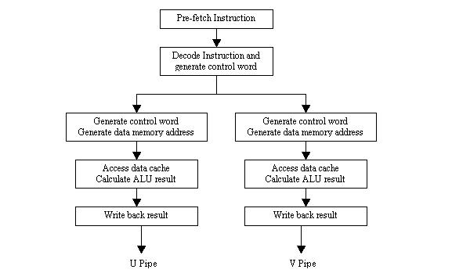
Pentium pipeline stages
11.Draw and explain the internal block diagram of 8279 chip

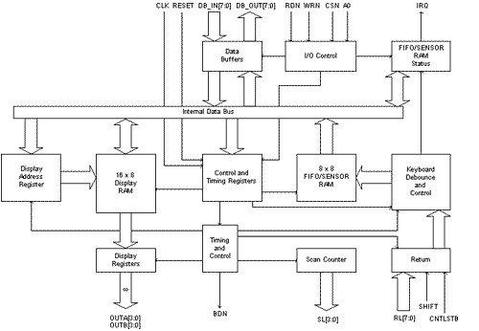

KEYBOARD SECTION

This section has eight lines (RL0-RL7) that can be connected to eight columns of a keyboard, plus two additional lines: Shift and CNTL/STB (Control/Strobe). The status of the SHIFT key and the Control key can be stored along with a key closure. The keys are automatically de-bounced, and the keyboard can operate in two modes: two-key lockout or N-key rollover. In the two-key lockout mode, simultaneous keys are recognized and their codes are stored in the internal buffer; it can also be set up so that no key is recognized until only one key remains pressed.
The keyboard section also includes 8*8 FIFO RAM. The FIFO RAM consists of 8 registers that can store 8 keyboard entries; each is then read in the order of entries. The statues logic keeps track of the number of entries and provides an IRQ (Interrupt Request) signal when the FIFO is not empty.

SCAN SECTION

The scan section has a scan counter and four scan lines (SL0-SL3). These four scan lines can be decoded using a 4-to-16 decoder to generate 16 lines for scanning. These lines can be connected to the rows of a matrix keyboard and the digit drivers of a multiplexed display.

DISPLAY SECTION

The display section has eight output lines divided into two groups A0-A3 and B0-B3. These lines can be used, either as a group of eight lines or as two groups of four, in conjunction with the scan lines for a multiplexed display. The display can be blanked by using the BD line. This section includes 16*8 displays RAM. The MPU can be read from or write into any of these registers.

MPU INTERFACE SECTION

This section includes 8 bidirectional data lines (DB0-DB7), one Interrupt line (IRQ), and 6 lines for interfacing, including the buffer address line (A0).
When A0 is high, signals are interpreted as control words or status; when A0 is low, signals are interpreted as data. The IRQ line goes high whenever data entries are stored in the FIFO. The signal is used to interrupt the MPU to indicate the availability of data.

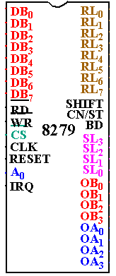

Pin out Definition 8279

- A0: Selects data (0) or control/status (1) for reads and writes between micro and 8279.
- BD: Output that blanks the displays.
- CLK: Used internally for timing. Max is 3 MHz.
- CN/ST: Control/strobe, connected to the control key on the keyboard.
- CS: Chip select that enables programming, reading the keyboard, etc.
- DB7-DB0: Consists of bidirectional pins that connect to data bus on micro.
- IRQ: Interrupt request, becomes 1 when a key is pressed, data is available.
- OUT A3-A0/B3-B0: Outputs that sends data to the most significant/least significant nibble of display.
- RD (WR): Connects to micro's IORC or RD signal, reads data/status registers.
- RESET: Connects to system RESET.
- RL7-RL0: Return lines are inputs used to sense key depression in the keyboard matrix.
- Shift: Shift connects to Shift key on keyboard.
- SL3-SL0: Scan line outputs scan both the keyboard and displays.

12.Briefly discuss about the operating modes of 8255 chip.
There are two basic modes of operation of 8255-I/O mode and Bit Set-Reset mode(BSR).
The BSR Mode is used to set or reset the bits in port C. The I/O mode is further classified into three modes
- mode 0
- Mode 1 and
- Mode 2

- In mode 0 all ports function as simple I/O ports.

- Mode 1 is a handshake mode whereby port A and/or port B use bits from port C as handshake signals. In this mode two types of I/O data transfer can be implemented: status check and interrupt.

- In mode 2 port A can be set up for bidirectional data transfer using handshake signals from port C and port B can be set up either in mode 0 or mode 1.

BSR (bit set/reset) mode
the BSR mode is concerned only with the eight bits of port C, which can be set or reset by writing an appropriate control word in the control register. The bit to be set or reset is selected by bit select flags B3,B2 and B1 of the CWR.A control word with bit D7=0 is recognized as a BSR control word and it does not alter any previously transmitted control word with bit D7=1. Thus, the I/O operations of ports A and B are not affected by a BSR control word.
b3 B2 B1 Selected Bits of port C
0 0 0 B0
0 0 1 B1
0 1 0 B2
0 1 1 b3
1 0 0 b4
1 0 1 b5
1 1 0 b6
1 1 1 b7

mode 0: simple output or input
This mode is also known as basic input/output mode.This mode providessimple input and output capability using each of the three ports.Data can be simply read from and written to the input and output ports respectively after appropriate initialisation.
B7 B6 B5 B4 B3 B2 B1 B0
1 | x | x | x

0-for BSR mode Bit select flags 0-Reset 1-Set

The salient features of this mode are-
- Two 8-bit ports(port A and port B) and two 4-bit ports(port C upper and lower) are available.The two 4-bit ports can be combinedly used as third 8-bit port.
- Any port can be used as an input or output port.
- Output ports are latched.Input ports are not latched.
- A maximum of four ports are available so that overall 16 I/O configurations are possible.

mode 1: input or output with handshake
This mode is also called as strobed input/output mode.In this mode the handshaking signals control the input or output action of the specified port.Port C lines PC0-PC2 provide strobe or handshake lines for port B.This group which includes port B and PC0-PC2 is called as port B for strobed data input/output.Port C lines PC3-PC5 provide strobe lines for port A.This group including port A port A and PC3-PC5 forms group A.Thus port C is utilized for generating handshake signals.
The features of this mode are
1. Two ports (A and B) function as 8-bit I/O ports .they can be configured either as input port or as output ports.
2. Each port uses three lines from port C as handshake signals the remaining two lines of port C can be used for simple I/O functions.
3. Input and output data are latched.
4. Interrupt logic is not supported.
in 8255 the specific lines from port C used for handshake signals vary according to the I/O function of a port.

mode 2: bidirectional data transfer
This mode is used primarily in applications such as data transfer between two computers or floppy disk controller interface. In this mode port A can be configured as the bidirectional port and port B either in mode 0 or in mode 1.
Port A uses five signals from port C as handshake signals for data transfer. The remaining three signals from port C can be used either as simple I/O or as handshake for port B.

13.Explain the interfacing of ADC with 8085. Also write an interrupt routine to read the o/p data of the converter,store it in the memory and continue to collect data for the specified n number of times.

(figure)

ADC converts analog signal to digital signal. The most commonly used is successive approximation type ADC. It includes three major elements the D/A converter, the successive approximation register(SAR) and the comparator. The conversion y=technique involves comparing the output of D/A convertor V_{O} with the analog input signal V_{in} . The digital input to the DAC is generated using the successive approximation method. When the DAC output matches the analog signal, the input to the DAC is the equivalent digital signal.

ADC can be interfaced to 8085 microprocessor system through tri-state buffer or port devices such as 8255. ADC0801 is a single channel 8 bit conversion type ADC. It has two analog inputs Vin(+) and vin(-). When the analog signal is single ended positive, then Vin(+) is used and Vin(-) is grounded. ADC requires an external clock. Typically the clock frequency is 640 kHz. The chip select signal is obtained form the address decoder of the 8085 system. The conversion is initiated when both chip select and write signal is low. The write control signal is used to reset the SAR of ADC to give SOC. The end of conversion by asserting interrupt signal low and this signal can be inverted to interrupt the 8085 microprocessor. The processor reads the digital data.

LDA 8000H : read data
MOV M,A : store data in memory
INX H : next memory location
DCR B : next count
STA 8000H : start next conversion
EI : enable interrupt again
RNZ : go back to main if counter not equal to 0
HLT : end

15. Discuss the different types of data memory at addressing with examples.

The Displacement Only Addressing Mode
The most common addressing mode, is the displacement-only (or direct) addressing mode. The displacement-only addressing mode consists of a 16 bit constant that specifies the address of the target location. The instruction mov al,ds:[8088h] loads the al register with a copy of the byte at memory location 8088h. Likewise, the instruction mov ds:[1234h],dl stores the value in the dl register to memory location 1234h:
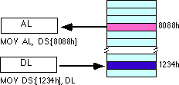
The displacement-only addressing mode is perfect for accessing simple variables.
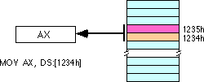
By default, all displacement-only values provide offsets into the data segment. If we want to provide an offset into a different segment, we must use a segment override prefix before the address. For example, to access location 1234h in the extra segment (es) we would use an instruction of the form mov ax,es:[1234h]. Likewise, to access this location in the code segment we would use the instruction mov ax, cs:[1234h]. The ds: prefix in the previous examples is not a segment override. The CPU uses the data segment register by default. These specific examples require ds: because of MASM's syntactical limitations.

The Register Indirect Addressing Modes
In 80x86, memory can be accessed indirectly through a register using the register indirect addressing modes. There are four forms of this addressing mode on the 8086, best demonstrated by the following instructions:
mov al, [bx]
mov al, [bp]
mov al, [si]
mov al, [di]
As with the x86 [bx] addressing mode, these four addressing modes reference the byte at the offset found in the bx, bp, si, or di register, respectively. The [bx], [si], and [di] modes use the ds segment by default. The [bp] addressing mode uses the stack segment (ss) by default.
Intel refers to [bx] and [bp] as base addressing modes and bx and bp as base registers (in fact, bp stands for base pointer). Intel refers to the [si] and [di] addressing modes as indexed addressing modes (si stands for source index, di stands for destination index). However, these addressing modes are functionally equivalent. This text will call these forms register indirect modes to be consistent.
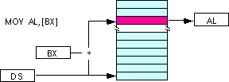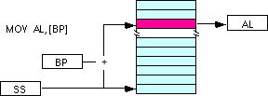
Note: the [si] and [di] addressing modes work exactly the same way, just substitute si and di for bx above.

Indexed Addressing Modes
The indexed addressing modes use the following syntax:
mov al, disp[bx]
mov al, disp[bp]
mov al, disp[si]
mov al, disp[di]
If bx contains 1000h, then the instruction mov cl,20h[bx] will load cl from memory location ds:1020h. Likewise, if bp contains 2020h, mov dh,1000h[bp] will load dh from location
ss:3020.
The offsets generated by these addressing modes are the sum of the constant and the specified register. The addressing modes involving bx, si, and di all use the data segment, the disp[bp] addressing mode uses the stack segment by default. As with the register indirect addressing modes, we can use the segment override prefixes to specify a different segment:
mov al, ss:disp[bx]
mov al, es:disp[bp]
mov al, cs:disp[si]
mov al, ss:disp[di]
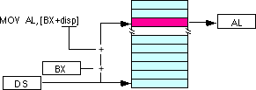

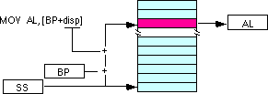
We may substitute si or di in the figure above to obtain the [si+disp] and [di+disp] addressing modes.
Based Indexed Addressing Modes
The based indexed addressing modes are simply combinations of the register indirect addressing modes. These addressing modes form the offset by adding together a base register (bx or bp) and an index register (si or di). The allowable forms for these addressing modes are
mov al, [bx][si]
mov al, [bx][di]
mov al, [bp][si]
mov al, [bp][di]
Suppose that bx contains 1000h and si contains 880h. Then the instruction
mov al,[bx][si]
would load al from location DS:1880h. Likewise, if bp contains 1598h and di contains 1004, mov ax,[bp+di] will load the 16 bits in ax from locations SS:259C and SS:259D.
The addressing modes that do not involve bp use the data segment by default. Those that have bp as an operand use the stack segment by default.
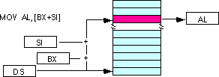
By substituting di in the figure above, we can obtain the [bx+di] addressing mode.
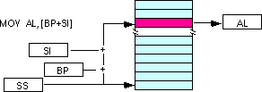
We substitute di in the figure above for the [bp+di] addressing mode.

Based Indexed Plus Displacement Addressing Mode
These addressing modes are a slight modification of the base/indexed addressing modes with the addition of an eight bit or sixteen bit constant. The following are some examples of these addressing modes:
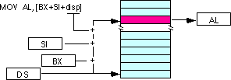
mov al, disp[bx][si]
mov al, disp[bx+di]
mov al, [bp+si+disp]
mov al, [bp][di][disp]
di may be substituted in the figure above to produce the [bx+di+disp] addressing mode.
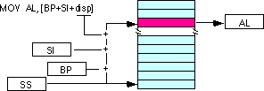
Suppose bp contains 1000h, bx contains 2000h, si contains 120h, and di contains 5. Then mov al,10h[bx+si] loads al from address DS:2130; mov ch,125h[bp+di] loads ch from location SS:112A; and mov bx,cs:2[bx][di] loads bx from location CS:2007.

16.
a)What is meant by segmentation?

The complete 1MB memory of 8086 is divided into 16 local segments.Each segment thus contains64KB of memory.There are 4 segment registers,viz code segment ,data segment,extra segment,stack segment.The code segment register is used for addressing a memory location in the code segment of the memory,data segment register points to the data segment of the memory,extra segment is another data segment,The stack segment register is used for addressing stack segment of the memory.While addressing any location in the memory bank,physical address is calculated fron 2 parts first is the segment address and second is the offset.The segment registers contain segment addresses an d pointers and base index registers contain offset.advantage of this scheme is that
-Instead of maintaining a 20 bit register ,the processor maintains 2 16 bit registers which is within the word length capacity of the machine.
-4 different segments so protection is possible.
-Access is easier

b)Write short note on instruction pipelining?

In case of 8085,once the opcode is fetched and decoded,the external bis remains free for some time,while the processor internally executes the instruction.This time slot is utilised in 8086 to achieve the overlapped fetch and execution cycles.Instruction queue is 6 bytes long, FIFO structure. The instructions form the queue are taken for decoding sequentially. Once a byte is decoded, the queue is rearranged by pushing it out and the queue status is checked for the possibility of the next opcode fetch cycle. While the opcode is fetched bus interface unit, the execution unit executes the previously decoded instruction concurrently. The microprocessor does not perform the next fetch instruction till at least two bytes of the instruction queue are emptied.By prefetching the instruction there is a considerable speeding up in instruction execution in 8086. This scheme is known as instruction pipelining.The bus interface unit along with execution unit thus forms a pipeline.The BIU thus manages the complete interface of execution unit with memory and I/O devices under the control of timing and control unit.

17.)
(a)Write an assembly language program for separating the given numbers into odd and even numbers.
ASSUME CS: CODE, DS:DATA
DATA SEGMENT
LIST DW 2357H, 0A579H, 0C322H,….
COUNT EQU 010H
DATA ENDS
CODE SEGMENT
START: XOR BX,BX
XOR DX, DX
MOV AX, DATA
MOV DS, AX
MOV CL, COUNT
MOV SI, OFFSET LIST
AGAIN: MOV AX,[SI]
ROR AX, 01
JC ODD
INC BX
JMP NEXT
ODD: INC DX
NEXT: ADD SI,02
DEC CL
JNZ AGAIN
CODE ENDS
END START

(b) Name the string instructions of 8086 processor and explain its functions.
A series of data bytes or words available in the memory at consecutive locations ,to be referred to collectively or individually, are called byte strings or word strings.For referring to a string ,two parameters are required,(a) starting or end address of the string and (b) length of the string(which is stored in CX register.

REP:Repeat instruction prefix
This instruction is used as a prefix to other instructions. the instruction to which the REP is prefix is executed repeatedly until the CX register becomes zero, after which the execution proceeds to the next instruction in sequence.

MOVSB/MOVSW:Move string byte or word
this moves a string of bytes/words pointed to by DS:SI pair(source) to the memory location pointed by the DS:SI pair(destination)

CMPS: Compare string byte or string word
It is used to compare two strings of bytes or words. The length of the string must be stored in the register CX. If both the byte or word strings are equal, zero flag is set .The byte by byte or word by word comparison continues till a mismatch is found. When a mismatch is found, the carry and zero flags are modified appropriately and the execution proceeds further.
SCAS: Scan string byte or string word
This instruction scans a string of bytes or words for an operand byte or word specified in the register AL or AX. The string is pointed to by ES:DI register pair. The length of the string is stored in CX .Whenever a match to the specified operand is found in the string, execution stops and the zero flag is set. If no match is found, the zero flag is reset
LODS :Load string byte or string word
The LODS instruction loads the AL/Ax register by the content of a string pointed to by DS:SI register pair. If it is a byte transfer (LODSB),the SI is modified by one and if it is a word transfer(LODSW),the SI is modified by two. No other flags are affected by this instruction.
STOS :Store string byte or string word
The STOS stores the AL/AX register contents to a location in the string pointed by ES:DI register –pair. The DI is modified according. No other flags are affected by this instruction

18.a) Give the additional features of 80286
(explain some more for your exam)

- 16-bit processor with 24 bit addressing 16 Mb of physical memory.
- Two modes
  - Real mode - Fast 8086
    - 1 Mb address limit
    - Powers up in Real mode
  - Protected mode - Protected Virtual Address Mode (PVAM)
    - OS or app must switch into PVAM
    - Address 16 Mb physical memory
    - Each task can address up to 1 GB of virtual memory.
    - 16384 (segments) * 64 (k) * 1024 (bytes) = 1 GB
  - processor must be RESET to switch from PVAM back to real mode
- 8086 register set plus extras
- Execution Unit (EU)
  - CS, DS, ES, SS
  - 16-bit ALU
- BUS Interface Unit (BIU) Adds:
  - Address Unit (AU) - computes the physical address
  - Instruction Unit (IU) - another prefetch queue
- Flag registers (two extra entries)
  - Bit 12-13: I/O privilege level (IOPL)
  - Bit 14: Nested Task (NT) Set = IRET to perform task switch
- Machine Status Word (MSW) switch to PVAM and 286 functions

- What is paging? How the physical address will be generated in memory paging? Explain

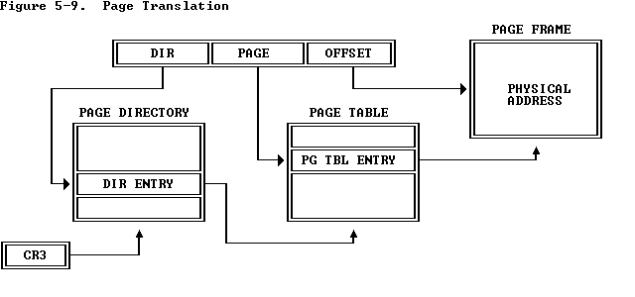
Paging operation

Paging is one of the memory management techniques used for virtual memory multitasking operating systems. The segmentation scheme may divide the physical memory in to variable size segments but the paging divides the memory in to fixed size pages. The segments are supposed to be the logical segments of the program, but the pages do not have any logical relation with the program. The pages are just the fixed size portions of the program module or data. The advantage of the paging scheme is that a complete segment of a task need not be in the physical memory at any time. Only a few pages of the segments, which are required currently for the execution, need to be available in the physical memory. Thus the memory requirement of the task is substantially reduced, relinquishing the available memory for other tasks. Whenever the other pages of the task are required for execution, they may be fetched from the secondary storage. The previous pages which are executed need not be available in the memory, and hence the space occupied by them may be relinquished for other tasks. Thus the paging mechanism provides an effective technique to manage the physical memory for multi tasking systems.

Paging unit The paging unit of 80386 uses a two level table mechanism to convert the linear address provided by the segmentation unit in to physical addresses. The paging unit converts the complete map of a task into pages, each of size 4K. The task is then handled in terms of its pages rather than segments. The paging unit handles every task in terms of three components namely page directory, page tables, page itself.

Page descriptor base register The control register CR₂ is used to store the 32 bit linear address at which the previous page fault was detected. The CR₃ is used as page directory physical base address register, to store the physical starting address of the page directory. The lower 12 bits of CR₃ are always 0 (page size is 2¹² = 4K) to ensure the page size aligned with the directory. The physical address of the current page directory is stored in the CPU register CR3, also called the page directory base register (PDBR). A move operation to CR₃ automatically loads the page table entry caches and a task switch operation, to load CR₀ suitably.

page directory This at the most 4K bytes in size. Each directory entry is of 4 bytes. Thus a total of 1024 entries are allowed in a directory. The following figure shows a typical directory entry. The upper 10bits of the linear address are used as an index to the corresponding page directory entry. The page directory entries, point to the page tables.

31 12 11 10 9 8 7 6 5 4 3 2 1 0

Page table address 31……….12 | OS reserved | 0 | 0 | D | A | 0 | 0 | U/  S | R/  W | P

Page Directory Entry

31 12 11 10 9 8 7 6 5 4 3 2 1 0

Page frame address 31……….12 | OS reserved | 0 | 0 | D | A | 0 | 0 | U/  S | R/  W | P

Page Table Entry

page tables Each page table is of 4Kbytes in size and may contain a maximum of 1024 entries. A page table entry contains the starting address of the page and the statistical information about the page as shown in the figure. The upper 20 bit page frame address is combined with the lower 12 bits of the linear address. The address bits A₁₂-A₂₁ are used to select the 1024 page table entries. The page tables can be shared between the tasks.
Page Frame Address
The page frame address specifies the physical starting address of a page. Because pages are located on 4K boundaries, the low-order 12 bits are always zero. In a page directory, the page frame address is the address of a page table. In a second-level page table, the page frame address is the address of the page frame that contains the desired memory operand.

The P bit of the above entries indicates, if the entry can be used in address translation. If P = 1 the entry can be used in address translation, otherwise it cannot be used. The P bit of the currently executed page is always high. The accessed bit A is set by 80386 before any access to the page. If A = 1 the page is accessed, otherwise it is un accessed. The D bit (the dirty bit), is set before a write operation to the page is carried out. The D bit is undefined for the page directory entries. The OS reserved bits are defined by the operating system software.
The User / Supervisor (U/S) bit and Read / Write (R/W) bit are used to provide protection. These bits can be decoded as shown in table to provide protection under the 4 level protection model. The level 0 is supposed to have the highest privilege, while the level 3 is supposed to have least privilege.

U/S | R/W | Permitted for level 3 | Permitted for levels 2,1 or 0
0 | 0 | None | Read/write
0 | 1 | None | Read/write
1 | 0 | Read only | Read/write
1 | 1 | Read/write | Read/write

20.Explain various features of pro Pentium processor

The Pentium Pro is a sixth-generation x86-based microprocessor developed and manufactured by Intel introduced in November 1995. It introduced the P6 microarchitecture and was originally intended to replace the original Pentium in a full range of applications. While the Pentium and Pentium MMX had 3.1 and 4.5 million transistors, respectively, the Pentium Pro contained 5.5 million transistors. Later, it was reduced to a more narrow role as a server and high-end desktop chip. The Pentium Pro was capable of both dual- and quad-processor configurations. It only came in one form factor, the relatively large rectangular Socket 8.
In 1997, the Pentium Pro was succeeded by the Pentium II processor, which was essentially a cost-reduced and re-branded Pentium Pro with the addition of MMX and enhanced 16-bit code performance. Costs were reduced by using standard SRAM cache chips running at half-speed, which increased production yields. The next year, in 1998, Intel split the market into three segments: budget workstations and home users, higher-end workstations and power users, and multi-processor capable servers. Those segments were served by the Celeron, the Pentium II, and the Pentium II Xeon, respectively.
The Pentium Pro (given the Intel product code 80521), was the first generation of the P6 architecture, which would carry Intel well into the next decade. The design would scale from its initial 150 MHz start, all the way up to 1.4 GHz with the "Tualatin" Pentium III. The Pentium Pro had a theoretical performance of 200 MFLOPS.

